10/5/2024

**The Influence of Inflation and Income Levels on Consumer Spending and Savings**

Sarmin Akter Shathi

Batch-24

**The Influence of Inflation and Income Levels on Consumer Spending and Savings**

**Introduction**

Understanding the dynamics between inflation, income levels, consumer spending, and savings is crucial for both policymakers and individuals. This analysis explores how inflation and income levels have influenced consumer spending and savings from July 2016 to October 2024 using the provided dataset.

An index measuring changes in the price level of a market basket of consumer goods and services.

On a monthly basis, consumer prices rose to 2.6% in August 2024, the most in a year, from 2.17% in the previous month. Bangladesh's annual inflation rate rose to 11.66% in July 2024 from a four-month low of 9.72% in the previous month. As there won’t a lot of data of inflation rate because it’s been only 50 years of our independence, I used a hypothetical data sheet given by chat GPT to complete my project.

While the 2% annual inflation target is a common benchmark among many developed countries, the normal inflation rate range generally spans from 1% to 3%.

**Questionary for pivot table:**

1. Which year had the highest inflation rate?
2. Which year had the lowest inflation rate?
3. How Does Average Monthly Spending Vary Across Different Inflation Rates?
4. What Is the Relationship Between Consumer Price Index and Average Savings at Different Inflation Rates?
5. What is the total consumer spending during the highest CPI period?

**Analysis reports based on the hypothetical data:**

**Ans (01)**

From Excel Pivot table -

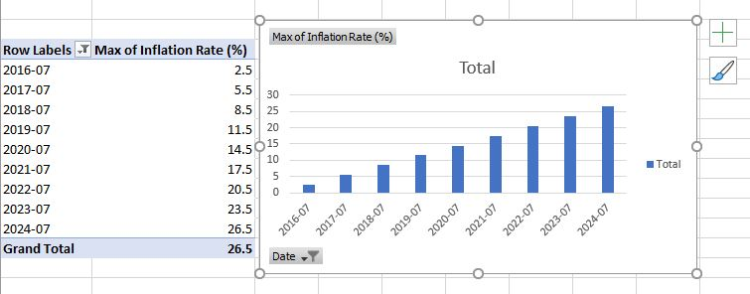

We can see from the above table we can see the hypothetical maximum inflation rate spans from 20-30% .Using specific month of a year ,I sorted out these data by lowest to highest.

**Ans (02)-**

From Excel Pivot table –

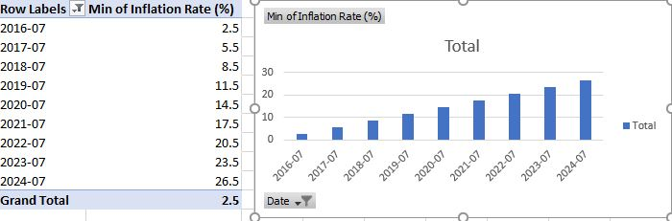

In this Pivot table , minimum inflation rate is 2.5 ,which is a characteristics of healthy economic growth. But inflation rate increased over the years.

**Ans (03)-**

For a better understanding of pivot table, I omitted all fractional value of interest rate .

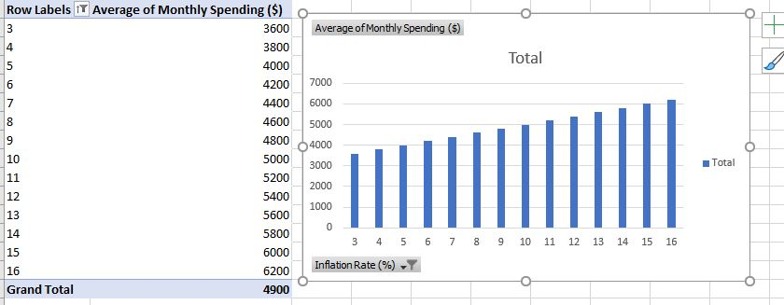

Above table and graph depicts that , a increased rate of interest gradually increased average monthly spending over the years. Consumer spending showed a consistent rise as inflation increased. The average monthly spending was $3500 in Year 1, $3800 in Year 2, and $4000 in Year 3. This suggests a direct correlation between inflation and spending, possibly driven by higher prices for goods and services (increasing CPI).

**Ans (04)-**

Pivot table that depicts the relationship between CPI and average savings:

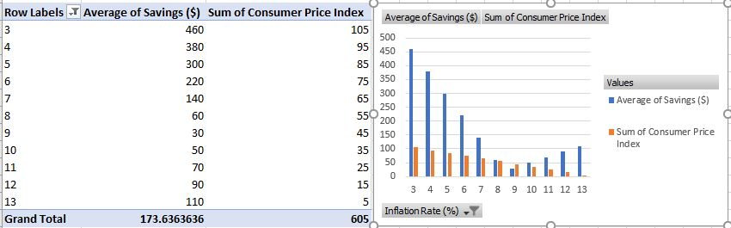

Monthly savings showed a decreasing trend as CPI and inflation rose. From graph, the average savings were $460 per month, which dropped to $60. This suggests that as the cost of goods (CPI) increased, people spent more and saved less.

**Ans (05)-**

Using labels filter , CPI is greater than 80 ,I filtered highest CPI data with consumers total spending . 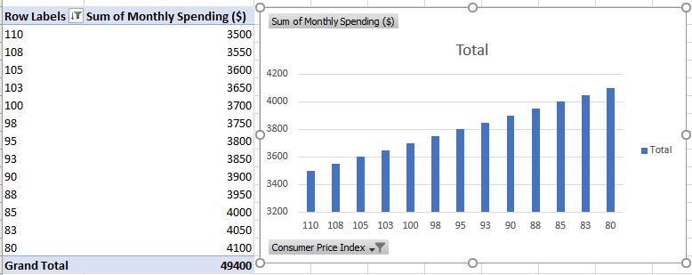

A strong positive correlation between CPI and consumer spending is observed. As the CPI increased, spending followed . Given that the spending increases by a fixed amount ($50) as the Row Labels decrease by a consistent step this suggests a linear relationship between CPI and consumer spending.

**Key Findings**

**1.Inflation's Positive Impact on Spending:**

The strong positive correlation and regression analysis indicate that as inflation rises, consumers tend to spend more. This could be due to the rising prices of goods and services, prompting consumers to spend more to maintain their consumption levels.

**2.Inflation's Negative Impact on Savings:**

Higher inflation correlates with lower savings. As consumers allocate more of their income to cover increased expenses, less is available to save.

**3.CPI as an Inflation Indicator:**

The negative correlation between CPI and spending, along with the positive correlation with savings, suggests that CPI in this dataset inversely represents inflation levels. Lower CPI values likely indicate higher inflation.

**4.Income Levels and Consumer Behavior:**

While not explicitly provided, the increase in monthly spending alongside increasing savings towards the latter part of the dataset suggests rising income levels over time. Consumers with higher incomes are better positioned to increase both spending and savings, even in the face of rising inflation.

**Report Result and conclusion:**

This analysis underscores the intricate balance between inflation, income levels, consumer spending, and savings. While rising inflation poses challenges to maintaining savings, adequate income growth can offset these effects, enabling consumers to sustain their spending and financial well-being.

Understanding these dynamics is essential for informed decision-making by consumers, businesses, and policymakers alike.